Experiment 4

Create table
Syntax: CREATE TABLE student_1 (student_id INT PRIMARY KEY, student_name VARCHAR(50), physics INT, chemistry INT, mathematics INT);
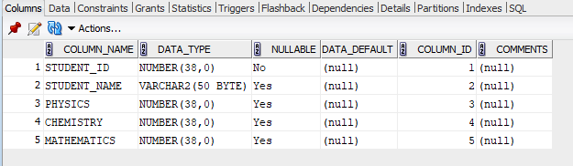

insert values:
INSERT INTO student_1 VALUES(1, 'Amit', 15, 18, 40);
INSERT INTO student_1 VALUES(2, 'Bina', 20, 22, 45);
INSERT INTO student_1 VALUES(3, 'Charan', 10, 14, 30);
INSERT INTO student_1 VALUES(4, 'Divya', 12, 11, 25);
INSERT INTO student_1 VALUES(5, 'Esha', 24, 23, 48);
INSERT INTO student_1 VALUES(6, 'Farhan', 18, 20, 35);
INSERT INTO student_1 VALUES(7, 'Gita', 14, 16, 28);
INSERT INTO student_1 VALUES(8, 'Hari', 11, 10, 20);
INSERT INTO student_1 VALUES(9, 'Isha', 22, 21, 42);
INSERT INTO student_1 VALUES(10,'Jay', 13, 12, 26);
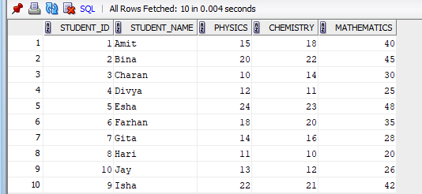
1) SELECT AVG(physics) from student_1;

2) SELECT MAX(mathematics) FROM student_1;


3) SELECT Min(chemistry) FROM student_1;
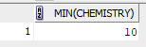

4)SELECT COUNT (*) FROM student_1 WHERE physics >= 12;


5)SELECT student_name FROM student_1 WHERE physics >= 12 AND chemistry >= 12 AND mathematics >= 25;
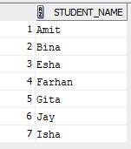

Alter table student_1 add(status varchar(30));
UPDATE student_1 SET status = 'Pass' WHERE physics >= 12 AND chemistry >= 12 AND mathematics >= 25;
UPDATE student_1 SET status = 'Fail' WHERE status IS NULL;
SELECT student_id, student_name, status FROM student_1;

6) SELECT student_id, student_name, (physics + chemistry + mathematics) AS total_marks, status FROM student_1 ORDER BY total_marks DESC;

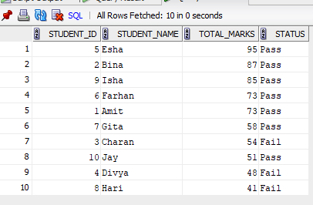
7)

